RYA Yachtmaster™ Theory Course
Next RYA Yachtmaster Theory course: Tues 28 November 2023 to Friday 05 January 2024
Course length: 6 weeks
Price: $1,590
Tuesday, Wednesday, Thursday, Friday mornings before work 05:00am to 07:30am

- Your RYA Yachtmaster™ Certificate is often the ultimate aim of aspiring skippers.
- It is a world recognised, highly respected qualification, proving your experience and competence as a skipper of a yacht or even a commercial vessel.
- It is endorsed by both AMSA (in Australia) and the MCA (in the United Kingdom) for commercial use up to 200 tonnes and less than 24metres. One can either apply for Yachtmaster™ Sail or Yachtmaster™ Power certificates, once you have completed the respective practical examination.
- Should a candidate wish to use her or his RYA Yachtmaster™ qualification as a commercial ticket, this qualification is only possible after “face-to-face” classroom tuition.
- You must have at least 40 hours in the classroom, including Zoom, if you are seeking RYA Yachtmaster™ Offshore certification with endorsement for commercial qualifications (This is done either with AMSA or MCA with a simple email application).
- Your theory course equips you to navigate safely on coastal and offshore passages of almost any length.
- This course will take your theory knowledge to the highest world standard required for the Yachtmaster_{TM} Coastal and Yachtmaster_{TM} Offshore practical exams, concentrating on advanced navigation and meteorology skills, and a detailed understanding of the IRPCS.
- Students in the southern hemisphere have a southern hemisphere version of our training materials, ensuring that your theory course is relevant to you. You will also receive the Northern Hemisphere training publications to practice in both locations. Yachting Directions is the only RYA Training Centre to include this in the course structure and price, and to include in your course fee, all your publications to facilitate your learning.
- Yachting Directions RYA Yachtmaster_{TM} Theory online course is 40 hrs minimum of face to face tuition, taught as 2.5 hrs per day from Monday to Thursday, inclusive, each week x 6 weeks. These classes are conducted over Zoom, online, from 5.00am until 7.30 am, or from 5.00pm to 7.30pm, with the recording made available later that day if you miss the live class. The recordings also facilitate easy revision before your assessment.
- The Theory Course size is a maximum of 10, occasionally the course size is 2 or 3.
- Pre-requisites: RYA Day Skipper or similar.
- This theory course is a pre-requisite for your RYA Yachtmaster_{TM} Coastal Skipper Practical Course. Or the Yachtmaster Offshore exam Preparation Course. Some students elect to do the Coastal Skipper Practical Course and then the Yachtmaster Offshore Exam preparation course. Although this is entirely a personal decision, we recommend this combination.
- The Syllabus:
  - Chartwork: Chart information and symbols, position fixing, course shaping and plotting, Zones of Confidence, use of traditional instruments, Rising and Dipping Distances,
  - Pilotage, use of soundings, lights and nav aids as “signposts”
  - Passage Planning and preparation,
  - Use of almanacs and admiralty publications,
  - Electronic aids to navigation, including Radar, AIS and GPS intensive,
  - Tides & anomalies, Streams & Currents, Tidal Curves, Secondary Port Calcs, Computation of Rates,
  - Meteorology, taking and interpreting forecasts, plotting weather systems,
  - IRPCS, (Known as The International Regulations for the Prevention of Collisions at Sea),
  - Navigation in Restricted Visibility,
  - Customs Regulations, Flag etiquette,
  - Magnetic Compass and Gyro Compass,
  - Weather predictions using a barometer and by observations
  - Customs and excise regulations for cruising abroad
  - Diesel engine and Electric Propulsion/Advanced Battery Systems,
  - Safety at Sea, Maintenance, Stability, Radar,

What is included? -The Yachting Directions Coastal & Offshore Yachtmaster shore-based course kit. It contains your Yachtmaster Shore-based Notes, RYA practice charts, Course Exercises, RYA Navigation Exercises for Northern Hemisphere, a soft lead pencil and eraser. You also receive the RYA Navigation Handbook, Weather handbook, International Regulations for the Prevention of Collision at Sea, and, Symbols and Abbreviations of Admiralty Charts and your course plotter (sometimes referred to as a Portland Plotter or Breton type plotter).

On successful completion of this course and the assessment you will receive the RYA Yachtmaster / Coastal Skipper shore-based certificate.

TEXTS AND EQUIPMENT included with your RYA Yachtmaster theory course

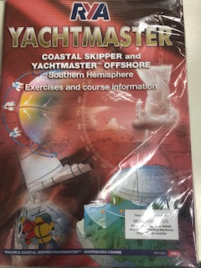  Course text  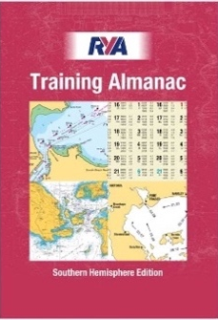  Included | 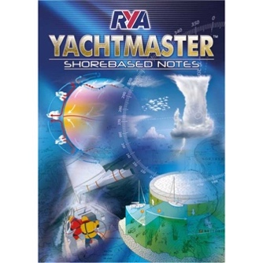Course text  Included |  | 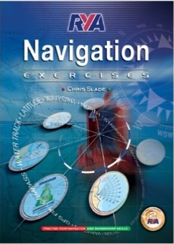  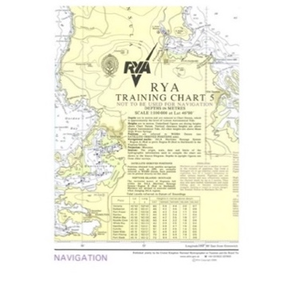 | 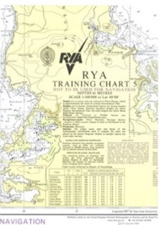  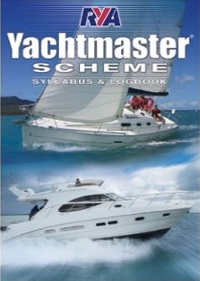
Included  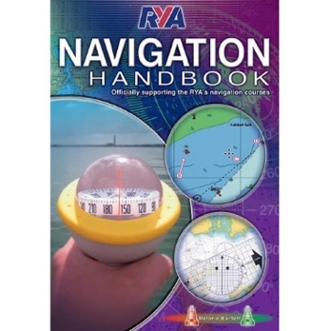  (rrp $20.00) | Included  (rrp $19.95) |  | Included Included  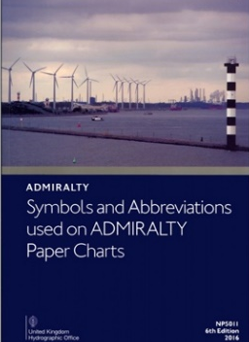  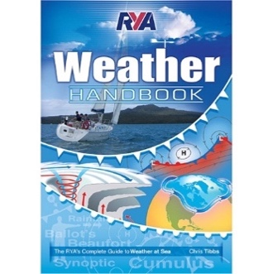  (rrp $49.95). (rrp $20.00)
(rrp $39.95) (rrp $70.00) (rrp 39.95)
Included Included Included

Our RYA Yachtmaster courses are conducted over blocks of 4 days per week over 6 weeks, with a final weekend to cap off your learning and to sit the exams.

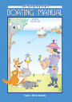
The Australian Boating Manual
$98.95

